|  |  |
| --- | --- |
| **Name:** |  |
|  | --------------------------------------------------------------------- |

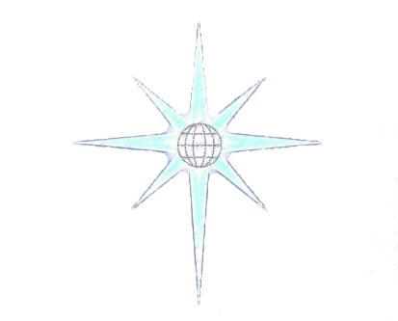

**Koios**

**Communication Review**

This form is an evaluation of the communication between the players and their teamwork. It is mainly filled out by the game master, but it can also be filled out by each player for further review.

**How was the overall communication?**

_______________________________________________________________________________________________________________________________________________________________________________________________________________________________________________________________________________________________________________________________________________________________________________________________________________________________________________________________________

**Did the team members endorse each other? Was it easy to name top 3 abilities for each team member?**

_______________________________________________________________________________________________________________________________________________________________________________________________________________________________________________________________________________________________________________________________________________________________________________________________________________________________________________________________________

**Did the players utilize their certs written down or relevant experience during the game play? Did they do it at the correct time?**

_______________________________________________________________________________________________________________________________________________________________________________________________________________________________________________________________________________________________________________________________________________________________________________________________________________________________________________________________________

**How was the communication between members when faced with a problem?**

_______________________________________________________________________________________________________________________________________________________________________________________________________________________________________________________________________________________________________________________________________________________________________________________________________________________________________________________________________

**Did they act respectful towards each other and play on each other strengths?**

_______________________________________________________________________________________________________________________________________________________________________________________________________________________________________________________________________________________________________________________________________________________________________________________________________________________________________________________________________

**More feedback?**

Please write some more extended feedback or comments here if you have any

______________________________________________________________________________________________________________________________________________________________________________________________________________________________________________________________________________________________________________________________________________________________________________________________________________________________________________________________________________________________________________________________________________________________________________________________________________________________________________________________________________________________________________________________________________________________________________________________________________________________________________________________________________________________________________________________________________